**Assignment 7:**

1. time1.c prints the current time of the system.

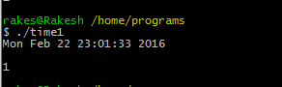

1. time2.c traps the SIGALRM signal after the time passed to the program.

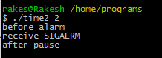

1. time3.c takes input and prints it to console if it is done in time passed as parameter. Else it terminates after the time passed to the program and that is used to set the timer. This is timer for blocking time.

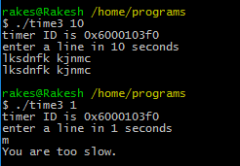

4.



Output:

